

**Dudley Safeguarding People Partnership (DSPP) PROTOCOL FOR THE MANAGEMENT OF SUSPICIOUS MARKS/BRUISING IN INFANTS WHO ARE NOT INDEPENDENTLY MOBILE**

**2020**

|  |  |
| --- | --- |
| Version Control | |
| Document Title | PROTOCOL FOR THE MANAGEMENT OF SUSPICIOUS MARKS/BRUISING IN INFANTS WHO ARE NOT INDEPENDENTLY MOBILE 2020 |
| Author | DSPP Business Unit |
| Version Dates | V3 |
| Date Approved | September 2020 |
| Due for Review | September 2022 |

**Protocol for the management of suspicious marks/bruising in infants who are not independently mobile**

1 **Introduction**

Infants who have yet to acquire independent mobility (rolling/crawling) should not have bruises without a clear explanation. Numerous serious case reviews, both locally and nationally, have identified the need for heightened concern about any bruising in any pre-mobile baby. Any bruising is likely to come from external sources and should raise child protection concerns. Less than 1% of babies younger than nine months of age show bruising, compared with 40% to 90% of children nine months of age and older[1]. Bruising to the face in a non-mobile infant may be a sentinel injury[2]

* **Not Independently Mobile** (this should be based on developmental rather than chronological age): a baby who is not crawling, bottom shuffling, pulling to stand, cruising or walking independently. Includes all babies and children who are not able to move independently, including children with a disability. Babies who can roll or sit independently are classed as non-mobile;
* **Bruising:** blood coming out of the blood vessels into the soft tissues, producing a temporary, non- blanching discolouration of skin however faint or small with or without other skin abrasions or marks. Colouring may vary from yellow through green to brown or purple. This includes petechiae (tiny red or purple non-blanching spots, less than two millimetres in diameter and often in clusters);
* **Minor injuries** may include (but are not confined to) torn frenulum; grazing; abrasions; minor cuts; blisters; injuries such as bruises, scratches, burns/scalds, eye injuries e.g. sub-conjunctival haemorrhages/corneal abrasions, bleeding from the nose or mouth, bumps to the head, ear injuries.

Any bruising, fractures, bleeding and other injuries such as burns should be taken as a matter of enquiry and potential abuse unless otherwise evidenced.

2 **Aim of protocol**

2.1 This protocol must be followed in all situations where an actual or suspected injury is noted in an infant who is not independently mobile.

2.2 This policy applies to all infants under the age of 12 months, and also to older children up to age 2 years who are not yet crawling, bottom shuffling, pulling to stand, cruising or walking independently.

3. **Target audience**

3.1 All those staff within the Dudley area whose work brings them into contact with young children.

4. **Action to be taken on identifying actual or suspected bruising**

4.1 If the infant appears seriously ill or injured;

* Seek emergency treatment at an A&E department.
* Notify Dudley Children’s Social Care via the MASH of your concerns and the child’s location.

4.2 In all other cases;

4.3 **Record what is seen**, using a body map or line drawing (if appropriate: Appendix A). In early years settings staff (nurseries, child minders etc) **staff cannot diagnose a bruise** but should clearly describe any suspected injuries i.e. *black, brown circular mark measuring 2cm in diameter, several purple blue round marks on the upper arm each measuring approximately 1cm in diameter.*

4.4 Record any explanation or other comments by the parent/carer word for word.

4.5 Inform parents/carers of your professional responsibility to follow Dudley and West Midlands safeguarding children policies and procedures and stress that any action by children’s social care will be informed by a paediatrician’s opinion. <http://westmidlands.procedures.org.uk/>

4.6 **Refer to children’s social care** who will take responsibility for further multiagency investigation including requesting a paediatric assessment and opinion (see appendix B).

5. **Action following referral**

5.1 Children’s Social Care will follow the DSPP safeguarding procedures. This will include gathering background information about the family from other agencies and arranging a medical assessment and opinion directly with a paediatrician.

5.2 The child must be seen on the day of referral for full paediatric assessment. This must include a detailed history from the carer, review of past medical history and family history including any previous reports of bruising, and enquiry about vulnerabilities within the family.

6. **Specific considerations**

6.1 Birth injury: both normal births and instrumental delivery may lead to development of bruising and of minor bleeding into the white of the eye. However, staff should be alert to the possibility of physical abuse within a hospital setting and follow this protocol if there is any doubt about the origin of the features seen.

6.2 Birthmarks: these may not be present at birth, and appear during the early weeks and months of life. Certain birthmarks, particularly Mongolian blue spots, can mimic bruising. Where there is uncertainty about the nature of a mark, the infant should be discussed with the primary care team in the first instance (GP, Health Visitor).

6.3 Self-inflicted injury: It is exceptionally rare for non-mobile infants to injure themselves during normal activity. Suggestions that a bruise has been caused by the infant hitting him/herself with a toy, falling on a dummy or banging against an adult’s body should not be accepted without detailed assessment by a paediatrician and social worker.

6.4 Injury from other children: it is unusual but not unknown for siblings to injure a baby. In these circumstances, the infant must still be referred for further assessment, which must include a detailed history of the circumstances of the injury, and consideration of the parents’ ability to supervise their children.

7. **Rationale and evidence base**

7.1 Bruising is the commonest presenting feature of physical abuse in children. Systematic review[3] of the literature relating to bruises in children shows that;

* Bruising is strongly related to mobility.
* Bruising in a baby who is not yet crawling, and therefore has no independent mobility, is very unusual.
* Only one in five infants who is starting to walk by holding on to the furniture has bruises
* Unintentional bruises in pre-mobile infants are rare, with a prevalence of <1% **(‘Those who don’t cruise rarely bruise’)**

The message from research is that Infants who have yet to acquire independent mobility (rolling/crawling) should not have bruises without a clear explanation (RCPCH 2020).[4]

7.2 The National Institute for Clinical Excellence (NICE) guideline ‘When to suspect child maltreatment’,[5] aimed at health professionals, categorises features that should lead staff to ‘consider abuse’ as part of a differential diagnosis, or ‘suspect abuse’ such that there is a serious level of concern. In relation to bruising, health professionals are advised to ‘suspect abuse’ and refer to children’s services in the following situations:

a) If a child or young person has bruising in the shape of a hand, ligature, stick, teeth mark, grip or implement.

b) If there is bruising or petechiae (tiny red or purple spots) that are not caused by a medical condition (for example, a causative coagulation disorder) and if the explanation for the bruising is unsatisfactory. Examples include:

* bruising in a child who is not independently mobile
* multiple bruises or bruises in clusters
* bruises of a similar shape and size
* bruises on any non-bony part of the body or face including the eyes, ears and buttocks
* bruises on the neck that look like attempted strangulation
* bruises on the ankles and wrists that look like ligature marks.
* Ear Bruising (APPENDIX C)

7.4 The NICE guideline3 also advises practitioners to ‘suspect abuse’ when features of injury such as bites, lacerations, abrasions, scars and thermal injuries are seen on a child who are not independently mobile and there is an unsuitable explanation.

7.5 Numerous serious case reviews, held following death or serious injury to a child in connection with abuse or neglect have identified situations where children have died because practitioners did not appreciate the significance of what appeared to be minor bruising in a non-mobile infant. A National analysis of Serious Case Reviews undertaken by SCIE (2016) [6] identified several instances in which identification of bruising did not result in a referral to Children’s Social Care.

The analysis within the SCR reports highlights a number of reasons for failing to make a referral to CSCin response to bruising in non-mobile babies including:

* a lack of understanding of child protection procedures, particularly among those working in out of hours GP surgeries
* a lack of professional curiosity and ‘respectful scepticism’ about explanations for bruising
* •second opinions not sought from more experienced clinicians.

“The younger the baby the more serious should be the concerns about how and why even very tiny bruises on any part of the child are caused’.

**Additional Reading**

Working Together to Safeguard Children 2018



**Appendix A Skin Map**

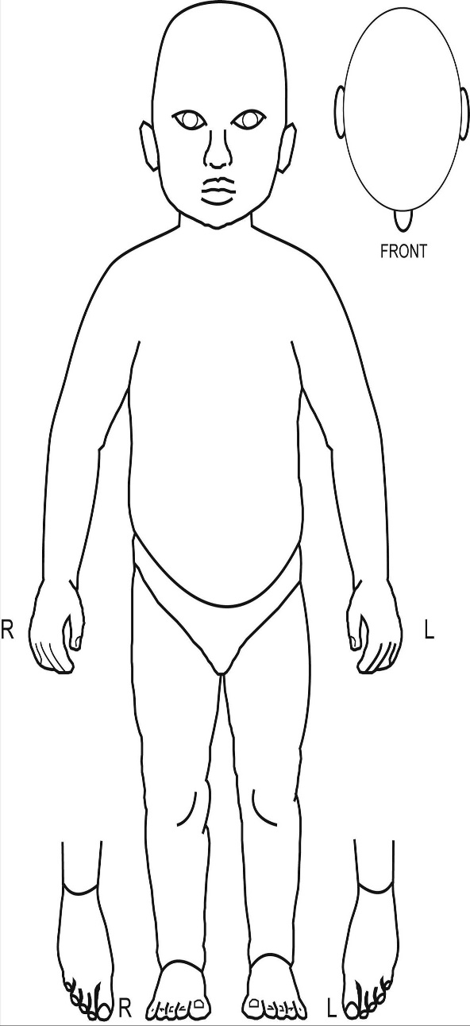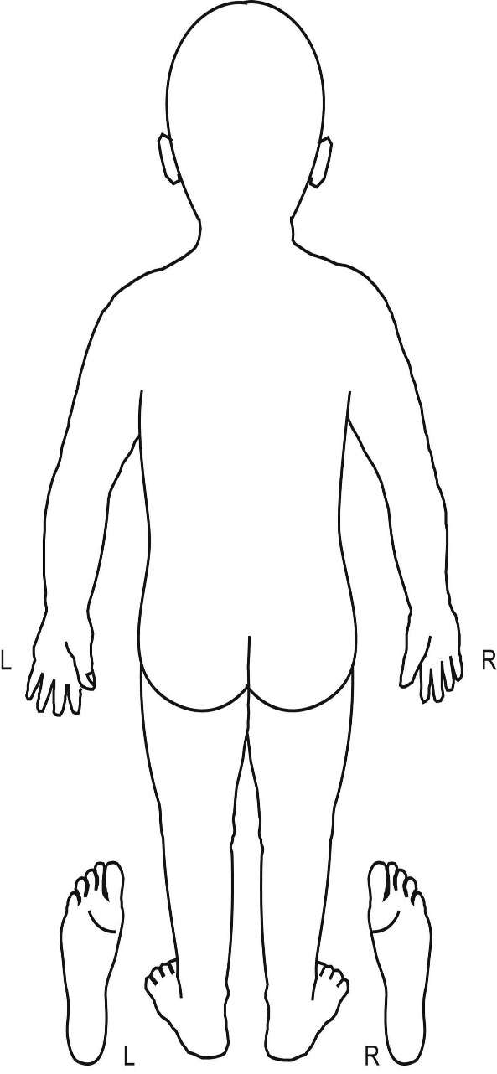

**Child’s name:**

**Date of birth:**

**Date/time of examination**

**Skin markings/injuries observed:**

**Who injuries observed by:**

**Name (PRINT)**

**Information recorded:**

**Date:**

**Time:**

**Name:**

**Signature:**

Appendix B **Flow Chart for the Management of actual or suspected bruising in infants who are not independently mobile**

**Practitioner observes bruise or suspicious mark**

**Suspect child maltreatment**

Accurately record what is seen and explanation/comments by parents/carers

An infant who is seriously ill or injured **refer immediately** to hospital.

Notify children’s social care

Explain to the family the reason for an immediate referral to children’s social care

Refer to Children’s social care for multi-agency assessment and information sharing.

**Same day paediatric assessment will be undertaken**

Follow DSPP procedures

https://safeguarding.dudley.gov.uk/safeguarding/child/work-with-children-young-people/safeguarding-children-procedures/

Contact Numbers for Local Authority Children’s Services Social Care

Call the children's services referral and advice service on **0300 555 0050** during office hours (9am - 5pm).Out of office hours contact the Emergency Duty Team on **0300 555 8574** or **in an emergency call 999.**

The Interagency Referral Form is for practitioners and those working with children and can be found at <https://safeguarding.dudley.gov.uk/report-it>

Please send completed form to the MASH at [MASH_Referrals@dudley.gov.uk](mailto:MASH_Referrals@dudley.gov.uk)

APPENDIX C Typical sites for accidental and non-accidental injury/bruising in older mobile children.

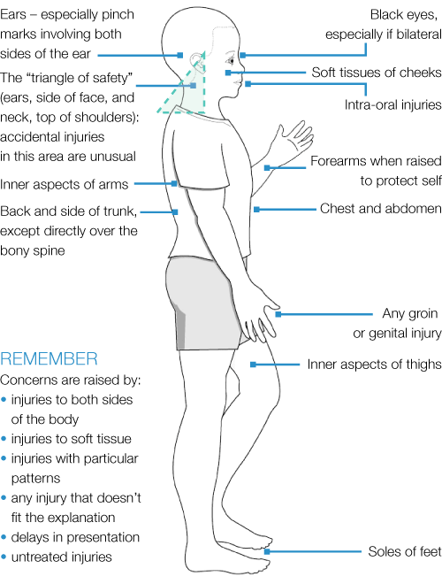 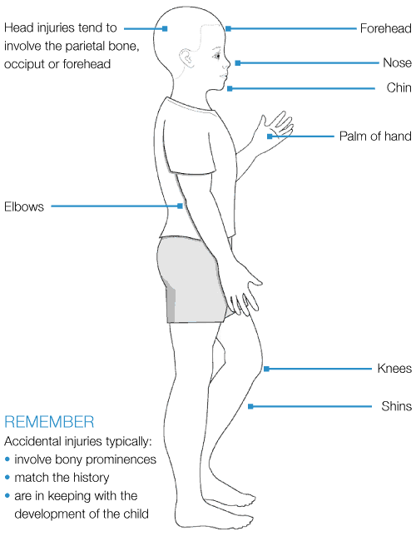

**Typical features of non-accidental injuries Typical features of accidental injuries**

**(injuries that should raise concerns)**

1. Labbé J, Caouette G. Recent skin injuries in normal children. Pediatrics. 2001;108(2):271–6. [PubMed], NSPCC (2012) Core-Info: Bruises on children.
2. Petska H.W., Sheets L.K., Knox B.L. Facial bruising as a precursor to abusive head trauma. Clin Pediatr (Phila) 2013; 52(1): 86-88.
3. Core Info Cardiff Child Protection Systematic Reviews <https://learning.nspcc.org.uk/research-resources/pre-2013/bruises-children-core-info-leaflet>
4. Child Protection Evidence Systematic review on Bruising March 2020 <https://www.rcpch.ac.uk/resources/child-protection-evidence-bruising>
5. When to suspect child maltreatment National Collaborating Centre for

   Women’s and Children’s Health 2009 ISBN 978-1-906985-15-8
6. SCIE (2016) Not making a referral after bruising to non-mobile babies: Practice issues from serious case reviews – learning into practice