

# ****Clutter Image Rating Scale****

**Bedroom** - Please select the photo that most accurately reflects the amount of clutter in the room

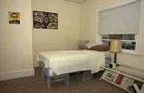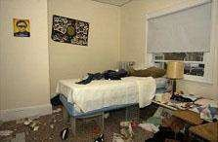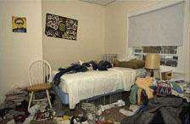

|  |  |  |
| --- | --- | --- |
| 1 | 2 | 3 |

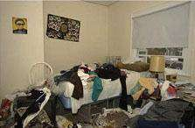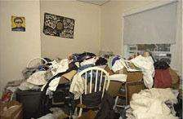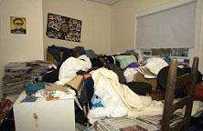

|  |  |  |
| --- | --- | --- |
| 4 | 5 | 6 |

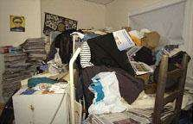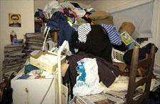

|  |  |  |
| --- | --- | --- |
| 7 | 8 | 9 |

**Kitchen** - Please select the photo that most accurately reflects the amount of clutter in the room

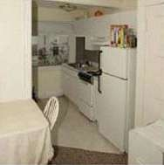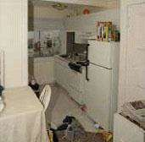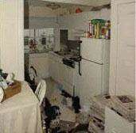

|  |  |  |
| --- | --- | --- |
| 1 | 2 | 3 |

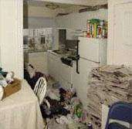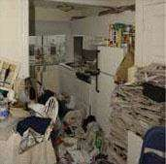

|  |  |  |
| --- | --- | --- |
| 4 | 5 | 6 |

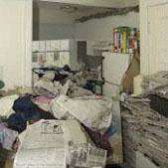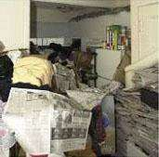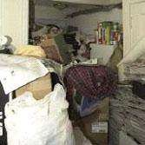

|  |  |  |
| --- | --- | --- |
| 7 | 8 | 9 |

**Living Room** - Please select the photo that most accurately reflects the amount of clutter in the room

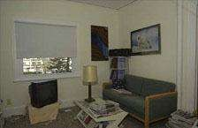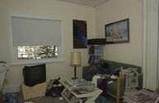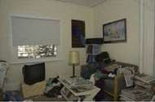

|  |  |  |
| --- | --- | --- |
| 1 | 2 | 3 |

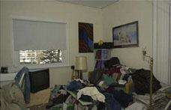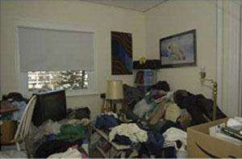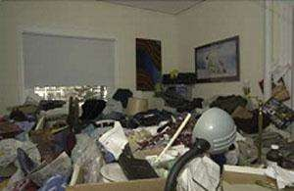

|  |  |  |
| --- | --- | --- |
| 4 | 5 | 6 |

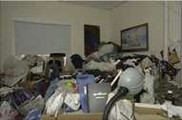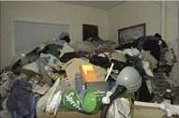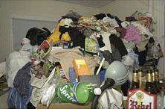

|  |  |  |
| --- | --- | --- |
| 7 | 8 | 9 |